Site Work Instruction

1. Description field should be big one in the middle of the form
2. Links should be applied
3. Delete Cost Estimation Box
4. Create change request button to be added.
5. Acknowledged will work same as approve concept, and will be visible only to assigned to person.
6. Assigned to me field should be there.
7. Introductory Note before Description of the SWI to there and it should say “These instructions are not intended to alter the contract amount nor vary the contract in any way. They are issued solely to ensure and facilitate compliance with the contract requirements. “. It’s an optional note
8. Instruction Number format - Project Number/Auto ID.
9. CC’d field to be included.
10. Create material Requisition button should be there.
11. Whenever the form has been acknowledged then it is closed.
12. Signed by Word to be removed.
13. Consultant – Rename to From and person name should be displayed
14. Contractor – Rename to “To” and person name should be displayed
15. For Create options only Title fields will be imported

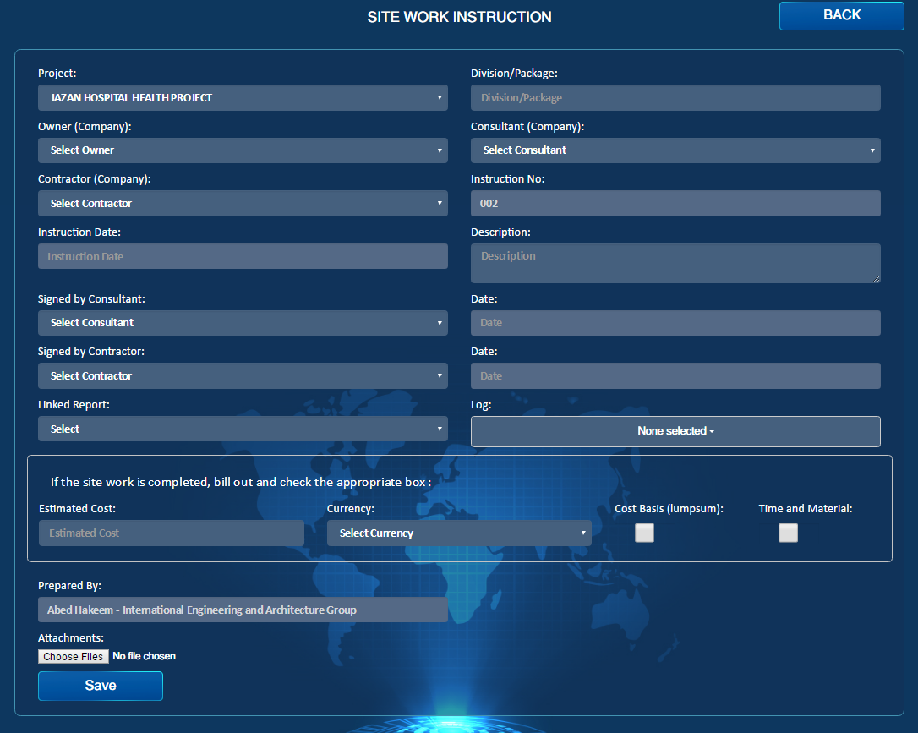

Create change request

Create Material request

Title

Draft

Email

PDF

Acknowledge

Submit

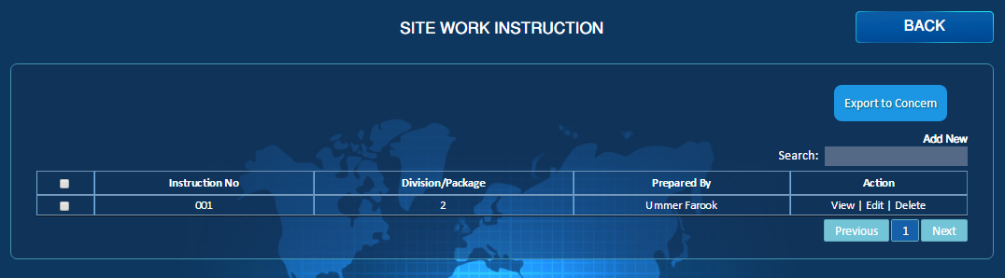

Draft

Transmittal Letter

No Action

Action Required

Assigned To Me